Ultrasound bioeffects literature review notes

* Understanding of ultrasound-tissue interactions contributes to safety, techniques(Dalecki, 2004)
* MI created to predict bioeffects (Apfel and Holland, 1991)
* Some imaging techniques are developed specifically for use with UCAs(Dalecki, 2004)
  + Ex. Harmonic imaging, and intermittent imaging.
* The first UCAs were air filled microbubbles wrapped in protein shell, but since then UCAs with less soluble gases, such as PFC, have been developed (Dalecki, 2004)
* Targeted UCAs are another area of interest because of their potential for localized drug delivery (also, molecular imaging and gene therapy).
* “US exposures used for diagnostic imaging are designed to minimize the interaction of the sound field with the tissue” to minimize potential bioeffects (Dalecki, 2004)
* Therapeutic US depends on US tissue interaction in order to get the intended bioeffect
* Bioeffects are either thermal vs nonthermal
* US energy is absorbed as heat.
* The nature of US-tissue interactions depends on both the tissue and US exposure properties
* Acoustic cavitation
  + US wave interacts with gas bubble (stabilized bubble or nucleus)
  + Gas bubbles rarely occur in nature outside of the lungs/intestines
  + UCAs are one way that gas bubbles can enter the body
* Pulmonary capillaries (Fung, p. 361)
  + are separated from air by a wall less than 1 $μ$ m thick
  + are distensible
  + i.e., they do not receive much support from surrounding tissue.
  + Organized in sheet form in the interaalveolar septa (Fung Figs. 5.2:1, 5.2:2, 8.10:1)
  + Vessels are crowded against one another.
  + Space between the vessels is filled with connective tissue
  + In plane view, there is not space to expand if blood pressure changes
    - Appear rigid to changes in blood pressure.
  + In cross section, the interaalveolar septa (capillary sheets) are thin-walled structures.
  + Under increased blood pressure, the membranes bulge out and the average thickness of the sheet will increase. (8.10:2 [Sobin et al. (1972)]
    - From figure: Top sheet thickness = 10.5 $μ$ m at $Δp$ = 2.69 kPa. Bottom sheet thickness = 6.0 $μ$ m at $Δp$ = 0.62 kPa (Sobin, 1972).
    - Transmural pressure: $Δp$ = local pressure of blood - the alveolar gas pressure.
  + References to relevant literature can be found in Fung and Sobin (1977).
  + When the transmural pressure is positive, $h=h_{0}+αΔp$
    - $h=$ thickness, $h_{0}, α$ are constants
* Young modulus of soft tissue is nearly proportional to the stress in the tissue.
* Paraphrasing: ‘The air-blood barrier is formed by the endothelium of the capillary, basement membrane, and type I pneumocytes (Zachary, 2006)
  + It has a mean thickness of 1.25 $μ$ m (Weibel and knight, 1964); Harmonic mean thickness (West et al., 1991)
  + Is a point of sound impedance mismatch
  + US hemorrhage (Fig. 4.)
    - Blood pool at surface
    - Hemorrhage area is a “cone” of varied depths
      * Base at pleural surface was intact and elevated
      * Underly ing alveoli are filled with hemorrhage
* Animal Studies
  + (Baggs et al., 1996; Child et al., 1990; Dalecki et al., 1997a, 1997b; Frizzell et al., 1994, 2003; Harrison et al., 1995; Hartman et al., 1990; Holland et al., 1996; Medicine. et al., 2000; O’Brien and Zachary, 1997; O’Brien et al., 2000, 2001a, 2001b; Penney et al., 1993; Raeman et al., 1993, 1996; Tarantal and Canfield, 1994; Zachary and O’Brien, 1995)(Kramer et al., 2001; O’Brien et al., 2003a, 2003b, 2005; Zachary et al., 2001a, 2001b)
  + Threshold studies
    - (O’Brien et al., 2001a, 2001b, 2003a, 2003b; Zachary et al., 2001a, 2001b)
* Damage appears to be independent of frequency, age (maybe not), and animal (O’Brien, 2007), suggesting it is plausible that it is happening in people too.
* Damage depends on the presence of gas in the tissue, because gas-free fetal lungs do not exhibit the lung damage observed in adult gas-filled lungs (Hartman et al., 1990)
* Damage, and acoustic impedance between the lung and intercostal tissue, depends on how filled the lungs are with gas. Inflated lungs were less damaged than half-inflated lungs, which were less damaged than deflated lungs (i.e., most damage) (O’Brien et al., 2002).
* “Introduction of additional cavitation nuclei (UCAs) in mice, did not increase the extent of lung hemorrhage. ” Quote - (Dalecki, 2004), citation - (Raeman et al., 1997)
* MI must be determined in water, it cannot be done in vivo.
* Chest wall attenuation for rabbits – 1.02 dB/mm; for rats,mice 0.59 dB/mm (O’Brien et al., 2006)
* Soft tissue attenuation – 0.7 dB/cm MHz (O’Brien, 2007)
* “Ultrasonic dosimetry’s objective is to relate magnitudes of specific quantities, such as intensity, acoustic pressure, particle displacement, etc., or perhaps some quantity yet to be developed, to the likelihood of occurrence of a biological alteration.”(O’Brien, 2007)
  + It is necessary to: (1) quantify the source outputs, (2) “determine the effect of the material on propagating energy, viz., reflections, refraction, scattering, absorption, etc., and (3) to relate quantitatively the first two items at the site of interest.”
* Hemmorhage threshold for adult mice is ~1 MPa at lung’s surface , 10 $μ$ s pulse, $f_{carrier}=2$ Mhz (Baggs et al., 1996) – Check this for better citation.
* Stress-failure analysis of capillary (West et al., 1991)
* Possibly similar to high-altitude pulmonary edema
* US timing studies suggest that US exposure modifies the tissue in such a way that it is more susceptible to non-thermal ultrasound damage (Raeman et al., 1993), longer exposures are more likely to be damaging.
* Threshold pressures for focused an unfocused fields appear to be the same (Raeman et al., 1993)
* Pressure thesholds for pulsed US and shock waves (almost entirely positive) are roughly the same (Hartman et al., 1990).
* “There is only a weak dependence of the threshold pressure and magnitude of the superthreshold effect on pulse repetition frequency and, therefore, the temporal average intensity (Raeman et al., 1993).
* “Increasing pulse length decreases threshold level. Increasing pulse length from 1 $μ$ s to 10 $μ$ s at 3.7 MHz resulted in a decrease in peak positive threshold pressure by only a factor of 2, even though the temporal average intensity and total on-time was also increased by a factor of 10 by the change” (Child et al., 1990; Raeman et al., 1993).
* “There is a weak dependence of the threshold and magnitude of the effect upon exposure duration. “ (Frizzell et al., 1994; Raeman et al., 1993)
* When one lung was hemorrhaged, then the other, the threshold for hemorrhage decreased significantly (O’Brien et al., 2003b)
* Total number of pulses is important to US-induced LH (O’Brien et al., 2005)
* Tables below from (O’Brien et al., 2006) of lung properties in various animals

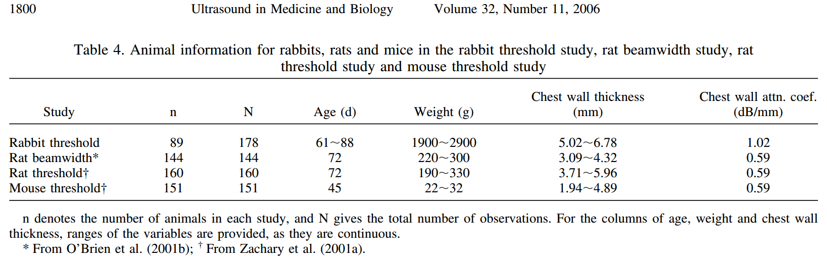

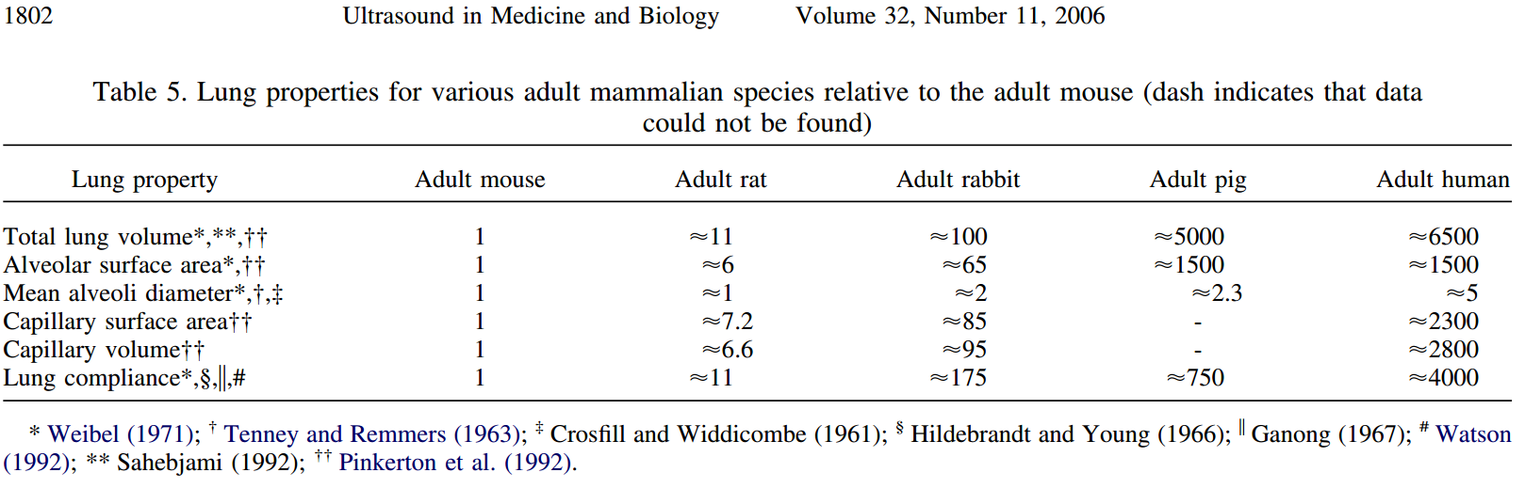

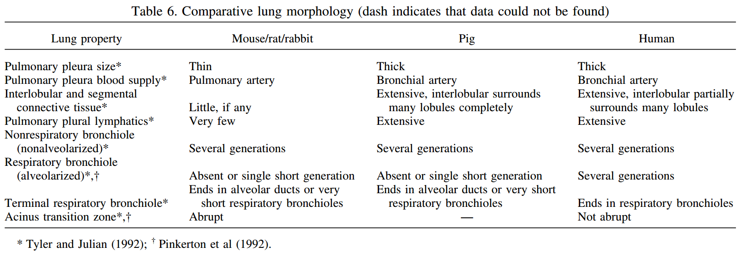

Theory: (Maybe Doug can help test)

The depth of the cone of hemorrhage will depend on the # of US pulses (given an appropriate amount of time for the system to adjust after each one.

Possible corresponding model would be based on time scales: (1) evolution of blood-air barrier (to the point of hemorrhage, i.e., strain failure), (2) Time for capillary to fill, (3) Time of US wave to pass.

Also, length scales (how deep does a single US pulse go?),

What is the size of a single alveoli?

What pressure is required to get the blood air-barrier to strain to the point of failure?

How many alveoli deep should we expect a single US wave to cause failure?

To do:

* Print fig. 4, (Zachary, 2006)
  + Measure how deep the cone goes, and how many alveoli that is
  + Approximate what the US pressure might be at that point.

To think about:

* L-R & T-B periodic boundary conditions to with air, surrounded by water to simulate alveoli.
* Look at how far single pulse goes vs multiple pulse
* How to look for cone behavior?
  + For a sheet of repeated, regular n-gons, for a planar wave coming in, compute the energy in each rn-gon from an incoming plane wave.
* How to simulate lung at exhale vs inhale, because there is a difference in injury (exhaled is more damaged).
* Determine maximum circulation deposition possible from a single pulse on a single interface as a means for quantifying US dosimetry for lung exposure.
  + What kind of surface would this be?

Length scales

Alveoli: 50 $μ$ m

Membrane: 1.25 $μ$ m

|  |  |  |
| --- | --- | --- |
| **What we know** |  | **What we don’t know / I could I try to find out** |
| Problem: US can cause lung hemorrhage   * Pulsed DUS (Zachary and O’Brien, 1995) * Continuous DUS (Zachary and O’Brien, 1995) * Shock wave lithotripsy (Hartman et al., 1990) | |  |
| Physical system   * Thin capillary sheets (thickness O($<μ$ m)) separating alveoli air pockets (Diameter $≈$ 200 $μ$ m) | |  |
| Damage mechanism  Probably mechanical   * Probably not cavitation   + Hyperbaric chamber didn’t help (O’Brien et al., 2000)   + Contrast agents didn’t make it worse (Raeman et al., 1997) * Probably not thermal   + US-induced lesions were different than laser induced injury (Zachary et al., 2006) | | **Q:** How is acoustic energy being deposited in the system?   * **H1:** US pressure gradients deposit circulation at thin air-blood barriers in the lungs, driving deformation of capillary sheets, leading to sufficient stress and strain for hemorrhage.   **E1:** Simulations of experimentally measured US wave, hitting thin sinusoidal, strip of water, surrounded by air.  **Note:** If this seems promising, perhaps would be a good dosimetric measure.   * **H2:** US wave performs p-v work on alveoli. US pressure causes expansion/compression of capillary sufficient to drive transmural pressure to point of stress failure in capillary sheets. * **E2:** Perform simple calculations to see how much a sinusoid or simple pressure rise/drop of 1 MPa amplitude could possibly grow/shrink a sphere of alveolar size. Compute maximum possible change in surface area and compare to expected growth from respiration and known failure limits. Compute maximum possible internal stress on the alveolar wall and transmural pressures, and compare to previously measured threshold values for pulmonary capillary (West et al., 1991). * **H3:** Acoustic radiation force punctures the alveolar walls * **E3:** ??? |
| Physical nature of injury (Zachary et al., 2006)   * Surface blood pooling   + Elliptical, red lesion * Conical injury area under visceral pleural surface * Visceral pleural surface was intact and elevated (hemorrhage) * Underlying alveoli filled with hemorrhage * No visible lesions other than alveolar hemorrhage * Injury appears to modify tissue in order to promote injury further injury (Raeman et al., 1993), possibly allowing waves to progressively reach deeper parts of the tissue by filling alveoli with hemorrhage. | | **Q.** (1) What is the cause of the conical shape of injury, (2) and what does its size (depth of hemorrhage) depend on?   * **A1:** Acoustic impedance mismatch that occurs at the blood-air barriers between alveoli results in transmission and reflection such that the acoustic field amplitude that is above a threshold amplitude takes on a conical shape. * **E1:** Use linear acoustics to predict the transmitted and reflected acoustic pressure amplitudes for air pockets separated by thin water membranes. (1a) Model adjacent alveoli as normal planar interfaces. (1b) Then model packed regular triangles, (1c) squares (faces oriented at $\frac{π}{4}$ relative to incoming plane wave.   2) Assuming areas of the field that have an amplitude above a given threshold are allowed to break, fill with hemorrhage, and have their impedance match that of water, repeat parts b,c of (1) to estimate the pattern of hemorrhage after N cycles/pulses have passed. |
| Physical dependencies of injury and threshold amplitude  Threshold amplitude decreases with ED   * Threshold amplitude decreases (weakly) with frequency * Increasing pulse length decreases threshold pressure(Child et al., 1990; Raeman et al., 1993) * Character of lesion is independent of frequency, PRF, and beamwidth (O’Brien, 2007) * Damage morphology is independent of age, species frequency (O’Brien, 2007). * Degree of damage decreases with how full the lungs are.   + This is likely due to the fact that acoustic impedance at the visceral pleura scales with how full the lungs are, so the more inhaled, the more energy is reflected (O’Brien et al., 2002). * Threshold pressures appear the same for focused and unfocused US (Raeman et al., 1993). Also for Pulsed US and shocks (almost entirely positive) (Hartman et al., 1990). * Once one lung is hemorrhaged, the threshold for hemorrhage in the other lung decreases significantly (O’Brien et al., 2003b).   + Why is still unknown, I’m guessing something biological, such as protein leakage inhibiting surfactant action. * Hemorrhage increases with total number of pulses (O’Brien et al., 2005). | |  |

Xylazine – alpha-2 receptor accuracy

Telazol –

Not much dependency on frequency

|  |  |  |  |  |  |  |  |  |  |  |  |
| --- | --- | --- | --- | --- | --- | --- | --- | --- | --- | --- | --- |
| **wave** | $$p^{+}$$**(MPa)** | $$p^{-}$$ $($**MPa $)$** | **Intensity $$\left(\frac{w}{m^{2}}\right)$$** | $f_{c}$**(MHz)** | $$t_{pulse}$$ $(μ$**s $)$** | **PRF** | **ED** | **Animal** | **Damage** | **Threshold**  **(MPa)** | **Reference** |
| Lithotripsy |  |  |  |  |  |  |  |  |  |  | (Hartman et al., 1990) |
| Pulse |  |  |  |  |  |  |  |  |  |  | (Child et al., 1990) |
| Pulse |  |  |  |  |  |  |  |  |  |  | (Raeman et al., 1993) |
| Pulse |  |  |  |  |  |  |  |  |  |  | (Penney et al., 1993) |
| Pulse |  |  |  |  |  |  |  | Monkey |  |  | (Tarantal and Canfield, 1994) |
| Continuous |  |  |  |  |  |  |  |  |  |  | (Zachary and O’Brien, 1995) |
| Pulse |  |  |  |  |  |  |  |  |  |  |
| Pulse |  |  |  |  |  |  |  | Minipigs |  |  | (Harrison et al., 1995) |
| Pulse |  |  |  |  |  |  |  | Mice |  |  | (Raeman et al., 1996) |
| Pulse | 1.5 |  |  | 2.0 |  |  |  | Neonatal Pig |  | 1.0 | (Baggs et al., 1996) |
| Pulsed Doppler |  |  |  |  |  |  |  |  |  |  | (Holland et al., 1996) |
| Color Doppler |  |  |  |  |  |  |  |  |  |  |

Apfel, R. E., and Holland, C. K. (**1991**). “Gauging the likelihood of cavitation from short-pulse, low-duty cycle diagnostic ultrasound,” Ultrasound Med. Biol., **17**, 179–185. Retrieved from http://www.ncbi.nlm.nih.gov/pubmed/2053214

Baggs, R., Penney, D. P., Cox, C., Child, S. Z., Raeman, C. H., Dalecki, D., and Carstensen, E. L. (**1996**). “Thresholds for ultrasonically induced lung hemorrhage in neonatal swine,” Ultrasound Med. Biol., **22**, 119–128. doi:10.1016/0301-5629(95)02035-7

Child, S. Z., Hartman, C. L., Schery, L. A., and Carstensen, E. L. (**1990**). “Lung damage from exposure to pulsed ultrasound,” Ultrasound Med. Biol., **16**, 817–825. doi:10.1016/0301-5629(90)90046-F

Dalecki, D. (**2004**). “Mechanical bioeffects of ultrasound,” Annu. Rev. Biomed. Eng., **6**, 229–248. doi:10.1146/annurev.bioeng.6.040803.140126

Dalecki, D., Child, S. Z., Raeman, C. H., Cox, C., and Carstensen, E. L. (**1997**). “Ultrasonically induced lung hemorrhage in young swine,” Ultrasound Med. Biol., **23**, 777–781. doi:10.1016/S0301-5629(97)00070-7

Dalecki, D., Child, S. Z., Raeman, C. H., Cox, C., Penney, D. P., and Carstensen, E. L. (**1997**). “Age dependence of ultrasonically induced lung hemorrhage in mice,” Ultrasound Med. Biol., **23**, 767–776. doi:10.1016/S0301-5629(97)00071-9

Frizzell, L. A., Chen, E., and Lee, C. (**1994**). “Effects of pulsed ultrasound on the mouse neonate: Hind limb paralysis and lung hemorrhage,” Ultrasound Med. Biol., **20**, 53–63. doi:10.1016/0301-5629(94)90017-5

Frizzell, L. A., Zachary, J. F., and O’Brien, W. D. (**2003**). “Effect of pulse polarity and energy on ultrasound-induced lung hemorrhage in adult rats,” J. Acoust. Soc. Am., **113**, 2912. doi:10.1121/1.1559176

Harrison, G. H. H., Eddy, H. A. A., Wang, J.-P. P., and Liberman, F. Z. Z. (**1995**). “Microscopic lung alterations and reduction of respiration rate in insonated anesthetized swine,” Ultrasound Med. Biol., **21**, 981–983. doi:10.1016/0301-5629(95)97511-Q

Hartman, C., Child, S. Z., Mayer, R., Schenk, E., and Carstensen, E. L. (**1990**). “Lung damage from exposure to the fields of an electrohydraulic lithotripter,” Ultrasound Med. Biol., **16**, 675–679. doi:10.1016/0301-5629(90)90100-Q

Holland, C. K., Deng, C. X., Apfel, R. E., Alderman, J. L., Fernandez, L. A., and Taylor, K. J. W. (**1996**). “Direct evidence of cavitation in vivo from diagnostic ultrasound,” Ultrasound Med. Biol., **22**, 917–925. doi:10.1016/0301-5629(96)00083-X

Kramer, J. M., Waldrop, T. G., Frizzell, L. A., Zachary, J. F., and O’Brien, W. D. (**2001**). “Cardiopulmonary function in rats with lung hemorrhage induced by pulsed ultrasound exposure,” J. Ultrasound Med., **20**, 1197–1206. Retrieved from http://www.scopus.com/inward/record.url?eid=2-s2.0-0035167787&partnerID=tZOtx3y1

Medicine., A. I. of U. in, In, I., and With, I. (**2000**). “Section 4--bioeffects in tissues with gas bodies American Institute of Ultrasound in Medicine,” J. Ultrasound Med., **19**, 97–108,154–168. Retrieved from http://www.jultrasoundmed.org/content/19/2/97.abstract

O’Brien, W. D. (**2007**). “Ultrasound-biophysics mechanisms,” Prog. Biophys. Mol. Biol., **93**, 212–255. doi:10.1016/j.pbiomolbio.2006.07.010

O’Brien, W. D., Frizzell, L. A., Schaeffer, D. J., and Zachary, J. F. (**2001**). “Superthreshold behavior of ultrasound-induced lung hemorrhage in adult mice and rats: role of pulse repetition frequency and exposure duration,” Ultrasound Med. Biol., **27**, 267–277. doi:10.1016/S0301-5629(00)00342-2

O’Brien, W. D., Frizzell, L. A., Weigel, R. M., and Zachary, J. F. (**2000**). “Ultrasound-induced lung hemorrhage is not caused by inertial cavitation,” J. Acoust. Soc. Am., **108**, 1290. doi:10.1121/1.1287706

O’Brien, W. D., Kramer, J. M., Waldrop, T. G., Frizzell, L. A., Miller, R. J., Blue, J. P., and Zachary, J. F. (**2002**). “Ultrasound-induced lung hemorrhage: Role of acoustic boundary conditions at the pleural surface,” J. Acoust. Soc. Am., **111**, 1102. doi:10.1121/1.1436068

O’Brien, W. D., Simpson, D. G., Frizzell, L. A., and Zachary, J. F. (**2001**). “Superthreshold behavior and threshold estimates of ultrasound-induced lung hemorrhage in adult rats: role of beamwidth,” IEEE Trans. Ultrason. Ferroelectr. Freq. Control, **48**, 1695–1705. doi:10.1109/58.971723

O’Brien, W. D., Simpson, D. G., Frizzell, L. A., and Zachary, J. F. (**2003**). “Threshold estimates and superthreshold behavior of ultrasound-induced lung hemorrhage in adult rats: role of pulse duration,” Ultrasound Med. Biol., **29**, 1625–1634. doi:10.1016/j.ultrasmedbio.2003.08.002

O’Brien, W. D., Simpson, D. G., Frizzell, L. A., and Zachary, J. F. (**2005**). “Superthreshold behavior of ultrasound-induced lung hemorrhage in adult rats: Role of pulse repetition frequency and exposure duration revisited,” J. Ultrasound Med., **24**, 339–348. Retrieved from http://www.scopus.com/inward/record.url?eid=2-s2.0-14644393629&partnerID=tZOtx3y1

O’Brien, W. D., Simpson, D. G., Moon-Ho Ho, Miller, R. J., Frizzell, L. A., and Zachary, J. F. (**2003**). “Superthreshold behavior and threshold estimation of ultrasound-induced lung hemorrhage in pigs: Role of age dependency,” IEEE Trans. Ultrason. Ferroelectr. Freq. Control, **50**, 153–169. doi:10.1109/TUFFC.2003.1182119

O’Brien, W. D., Yang, Y., Simpson, D. G., Frizzell, L. a., Miller, R. J., Blue, J. P., and Zachary, J. F. (**2006**). “Threshold estimation of ultrasound-induced lung hemorrhage in adult rabbits and comparison of thresholds in mice, rats, rabbits and pigs,” Ultrasound Med. Biol., **32**, 1793–1804. doi:10.1016/j.ultrasmedbio.2006.03.011

O’Brien, W. D., and Zachary, J. F. (**1997**). “Lung damage assessment from exposure to pulsed-wave ultrasound in the rabbit, mouse, and pig,” IEEE Trans. Ultrason. Ferroelectr. Freq. Control, **44**, 473–485. doi:10.1109/58.585132

Penney, D. P., Schenk, E. A., Maltby, K., Hartman-Raeman, C., Child, S. Z., and Carstensen, E. L. (**1993**). “Morphological effects of pulsed ultrasound in the lung,” Ultrasound Med. Biol., **19**, 127–135. doi:10.1016/0301-5629(93)90005-9

Raeman, C. H., Child, S. Z., and Carstensen, E. L. (**1993**). “Timing of exposures in ultrasonic hemorrhage of murine lung,” Ultrasound Med. Biol., **19**, 507–512. doi:10.1016/0301-5629(93)90126-9

Raeman, C. H., Child, S. Z., Dalecki, D., Cox, C., and Carstensen, E. L. (**1996**). “Exposure-time dependence of the threshold for ultrasonically induced murine lung hemorrhage,” Ultrasound Med. Biol., **22**, 139–141. doi:10.1016/0301-5629(95)02036-5

Raeman, C. H., Dalecki, D., Child, S. Z., Meltzer, R. S., and Carstensen, E. L. (**1997**). “Albunex Does Not Increase the Sensitivity of the Lung to Pulsed Ultrasound,” Echocardiography, **14**, 553–557. doi:10.1111/j.1540-8175.1997.tb00764.x

Tarantal, A. F., and Canfield, D. R. (**1994**). “Ultrasound-induced lung hemorrhage in the monkey,” Ultrasound Med. Biol., **20**, 65–72. doi:10.1016/0301-5629(94)90018-3

West, J. B., Tsukimoto, K., Mathieu-Costello, O., and Prediletto, R. (**1991**). “Stress failure in pulmonary capillaries,” J. Appl. Physiol., **70**, 1731–1742. Retrieved from http://www.ncbi.nlm.nih.gov/pubmed/2055852

Zachary, J. F., Blue, J. P., Miller, R. J., Ricconi, B. J., Eden, J. G., and O’Brien, W. D. (**2006**). “Lesions of ultrasound-induced lung hemorrhage are not consistent with thermal injury,” Ultrasound Med. Biol., **32**, 1763–1770. doi:10.1016/j.ultrasmedbio.2006.06.012

Zachary, J. F., Frizzell, L. A., Norrell, K. S., Blue, J. P., Miller, R. J., and O’Brien, W. D. (**2001**). “Temporal and spatial evaluation of lesion reparative responses following superthreshold exposure of rat lung to pulsed ultrasound,” Ultrasound Med. Biol., **27**, 829–839. doi:10.1016/S0301-5629(01)00375-1

Zachary, J. F., and O’Brien, W. D. (**1995**). “Lung Lesions Induced by Continuous- and Pulsed-Wave (Diagnostic) Ultrasound in Mice, Rabbits, and Pigs,” Vet. Pathol., **32**, 43–54. doi:10.1177/030098589503200106

Zachary, J. F., Sempsrott, J. M., Frizzell, L. A., Simpson, D. G., and O’Brien, W. D. (**2001**). “Superthreshold behavior and threshold estimation of ultrasound-induced lung hemorrhage in adult mice and rats,” IEEE Trans. Ultrason. Ferroelectr. Freq. Control, **48**, 581–592. doi:10.1109/58.911741